<!--This file created 2:29 PM 10/29/97 by Claris Home Page version 2.0-->7.1 Project
Discovering the Number e for Yourself

You can investigate the value of e by approximating the value of a such that

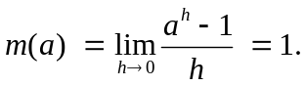

You need only use available technology to calculate (with appropriate fixed values of a) values of the function 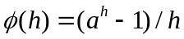 with h sufficiently small that you can recognize (to appropriate accuracy) the value of the limit.

For instance, if you calculate 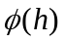 with a = 2 and with a = 3 for 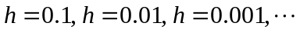, you should find that

It follows that the mysterious number e for which 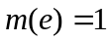 is somewhere between 2 and 3. Interpolation between the values suggests that
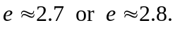

Investigate the values 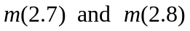 to verify the entries shown in Fig. 7.1.21. Continue in this way to close in on the number e. Don't quit until you're convinced that 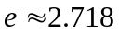 accurate to three decimal places.

In the paragraphs that follow, we illustrate the use of available technology to calculate values of the function efficiently so as to investigate the limit in (1) for appropriate values of the constant a.

Using a Graphing Calculator
We need only define Y1 = (A^H - 1)/H. Then the iteration shown in the calculator screen at the top of the next page, starting with 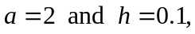 indicates that 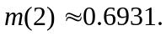 After the iteration command H/10H : Y1 is entered, each re-entry reduces h by a factor of 10 and recalculates the value of 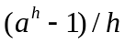.

You need only change the value of a entered in the first line, then repeat this iteration procedure to approximate each of the values of 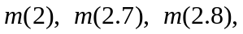 and so on.

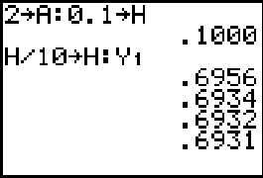

Using Maple

We need only define

phi := h -> (a^h - 1)/h;

and initialize:

a := 2: h := 1:
Digits := 20: # for greater accuracy

Then the following iteration indicates that

h := h/10: evalf(phi(h));
.717734625362931642

h := h/10: evalf(phi(h));
.69555500567188088

h := h/10: evalf(phi(h));
.6933874625806325

h := h/10: evalf(phi(h));
.693171203765692

h := h/10: evalf(phi(h));
.69314958283057

h := h/10: evalf(phi(h));
.6931474207865

Each repetition reduces h by a factor of 10 and recalculates the value of .

You need only change the value of a entered in the first line, then repeat this iteration procedure to approximate each of the values of and so on.

Using Mathematica

We need only define

phi[h_] := (a^h - 1)/h

and initialize:

a = 2; h = 1.0;

Then the following iteration indicates that

h = h/10; phi[h]
0.71735

h = h/10; phi[h]
0.695555

h = h/10; phi[h]
0.693387

h = h/10; phi[h]
0.693171

h = h/10; phi[h]
0.69315

h = h/10; phi[h]
0.693147

Each repetition reduces h by a factor of 10 and recalculates the value of .

You need only change the value of a entered in the first line, then repeat this iteration procedure to approximate each of the values of and so on.

Using MATLAB

We need only initialize

a = 2; h = 1;

and then iterate:

h = h/10; (a^h - 1)/h
ans = 0.7177

h = h/10; (a^h - 1)/h
ans = 0.6956

h = h/10; (a^h - 1)/h
ans = 0.6934

h = h/10; (a^h - 1)/h
ans = 0.6932

h = h/10; (a^h - 1)/h
ans = 0.6931

h = h/10; (a^h - 1)/h
ans = 0.6931

Each repetition reduces h by a factor of 10 and recalculates the value of .

You need only change the value of a entered in the first line, then repeat this iteration procedure to approximate each of the values of and so on.

